How to use idTracker
- Convert video to AVI format using VLC media player and save to local drive of computer. To convert multiple files at once, open separate VLC instances and run one video in each. Label AVI_videonumber

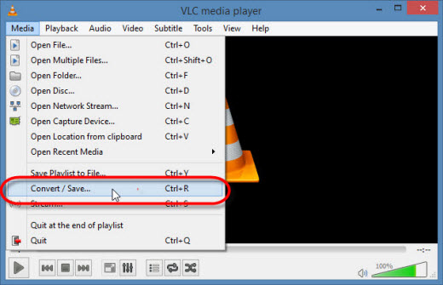
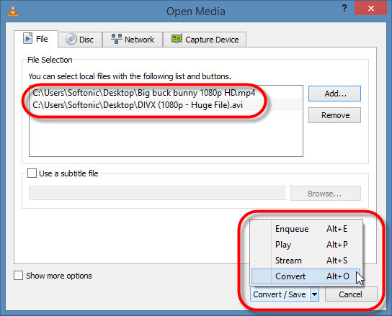
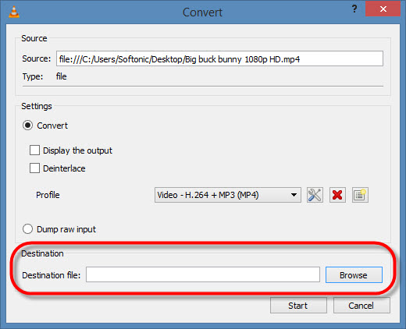
Convert to AVI (you may need to use advanced settings to create and AVI output in the dropdown if this is the first time you are doing this).
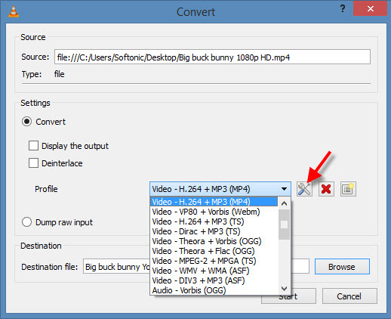
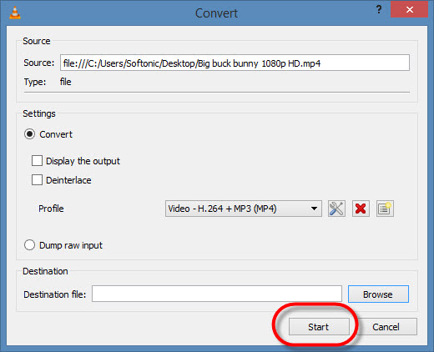

- Upload AVI video to idTracker. Double click ID tracker and select video. To concatenate longer videos, call then File1, File2, etc. Make a folder for the vole being tracked. If imaging, add AVI to this folder. At the end, put all output files in here and move into appropriate Behavior Scored folder.
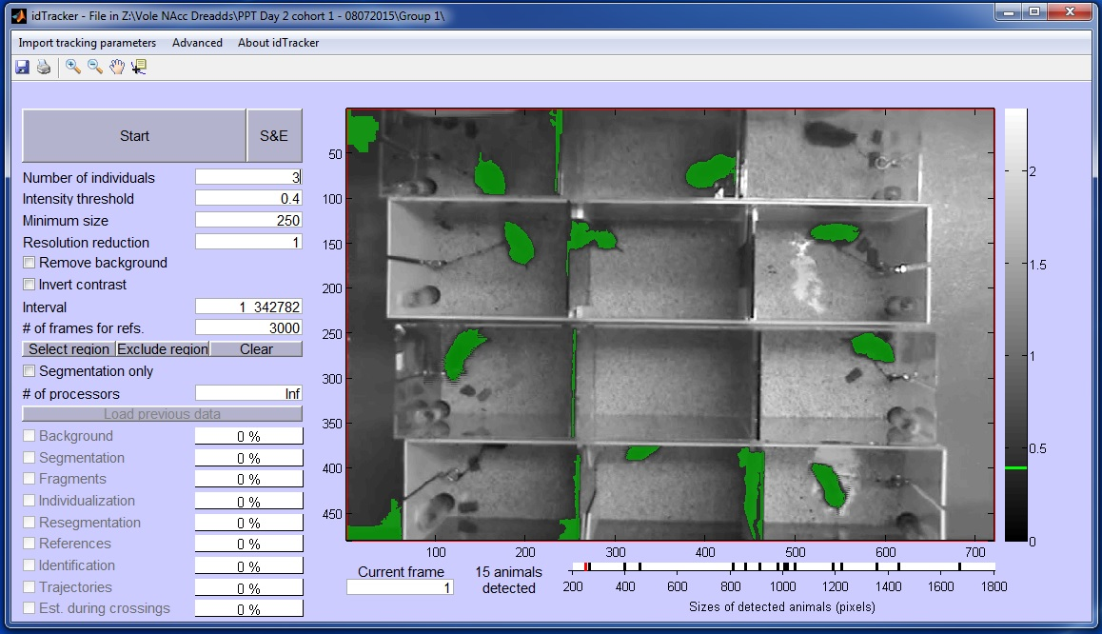
- Indicate number of individuals.
- Change intensity threshold until reliably identifies animals. Change the frame by typing a few different numbers in under “current frame” to ensure the setting work across a range of frames (start with 0.4).
- Set minimum size. For social interaction videos, try 2000 – 4000 pixels. For PPT, try 100 – 250.
- Set the resolution reduction so that the reduced size of the animal is under 2000. Reduction = n. size = total pixels/n^2. Use 10 or 15 for most social videos. This is not needed for PPT.
- Uncheck remove background.
- Set the interval to begin when the second animal is dropped into the frame or dividers are removed. Set it to end at appropriate frame.
- Leave # of frames for reference at 3000.
- Click select region. Select polygon for “shape of region”. Define region and hit enter when done. Clear and repeat if needed.
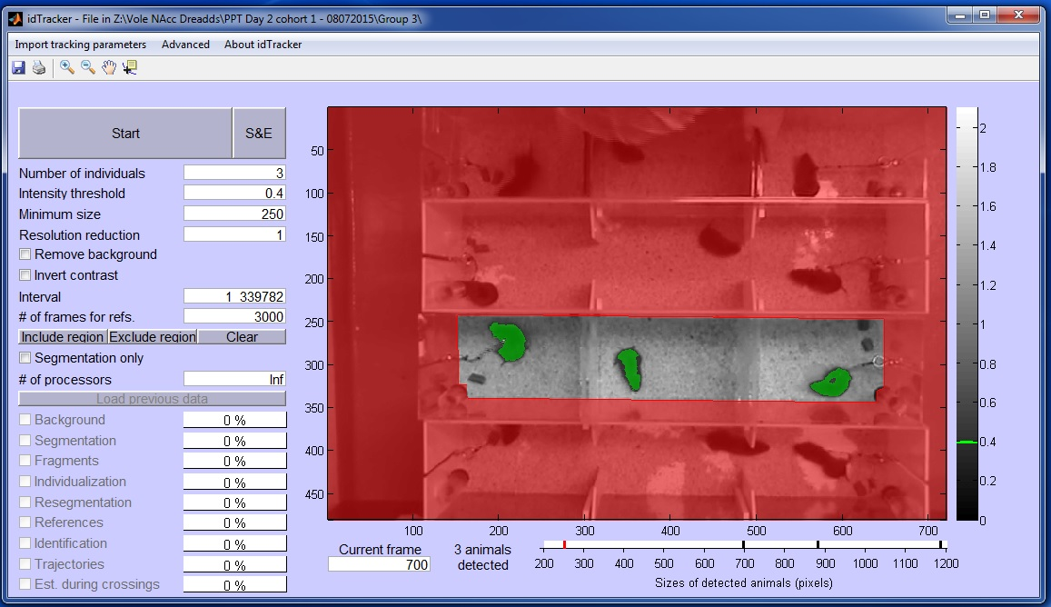
- Hit Run!

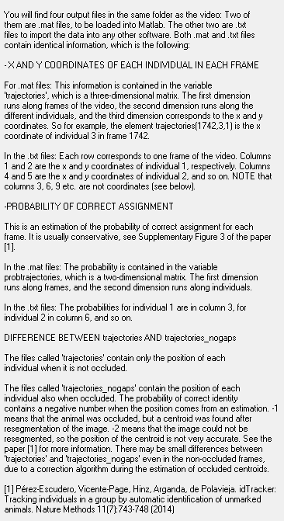

How to analyze idTracker data
- Draw diagram representative of test chambers include the animals # and label each animal with either P (partner), M (middle), N (novel). Middle is the test animal, “Partner” is the pair bonded partner of the test animal and “Novel” is the novel animal in the Partner Preference Test (PPT)
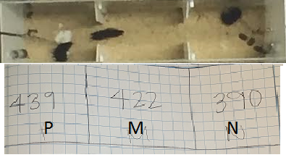
- Select Vole # file
- select movie.fig file
- run w/ no gaps
The video file will come up and the animals in the video will have number (1,2,3) labels. This is what allows the program to track the animal’s movements.
- On your drawn out diagram, label the boxes with the corresponding # the animal is label with in the tracking video (1,2, or 3)
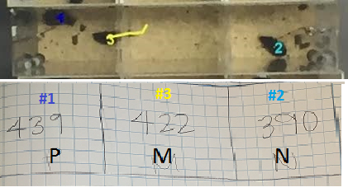
-then close out of these files
- Open ID Tracker
-Run
-select AVI movie file associated with the Vole you are analyzing
5) Once the video starts up, reduce intensity threshold to .01 and go to a frame where the researchers cannot be seen.
6) click data cursor button
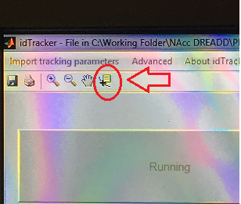
7) find coordinates for the middle box that the vole you are analyzing is placed into. (X₁, Y₁), (X₂, Y₂), (X₃, Y₃), (x₄, Y₄) and record this information onto you diagram.
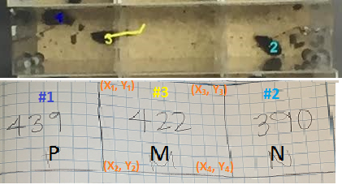
8) Next, you need to input this information into the “PPT IDtracker PW” excel sheet
- There are two different excel sheets for this: NovMidPtnr & PtnrMidNov. Depending on the order of your animals will decided which excel sheet you use. BE CAREFUL the calculations are made based on the order so it is EXTREMEMLY important you are using the correct excel sheet.
9) You are starting in the “Overall” tab (1): In the yellow box next to “Order” (2) towards the top of the document input the number of the vole next to their label (partner, novel, test)
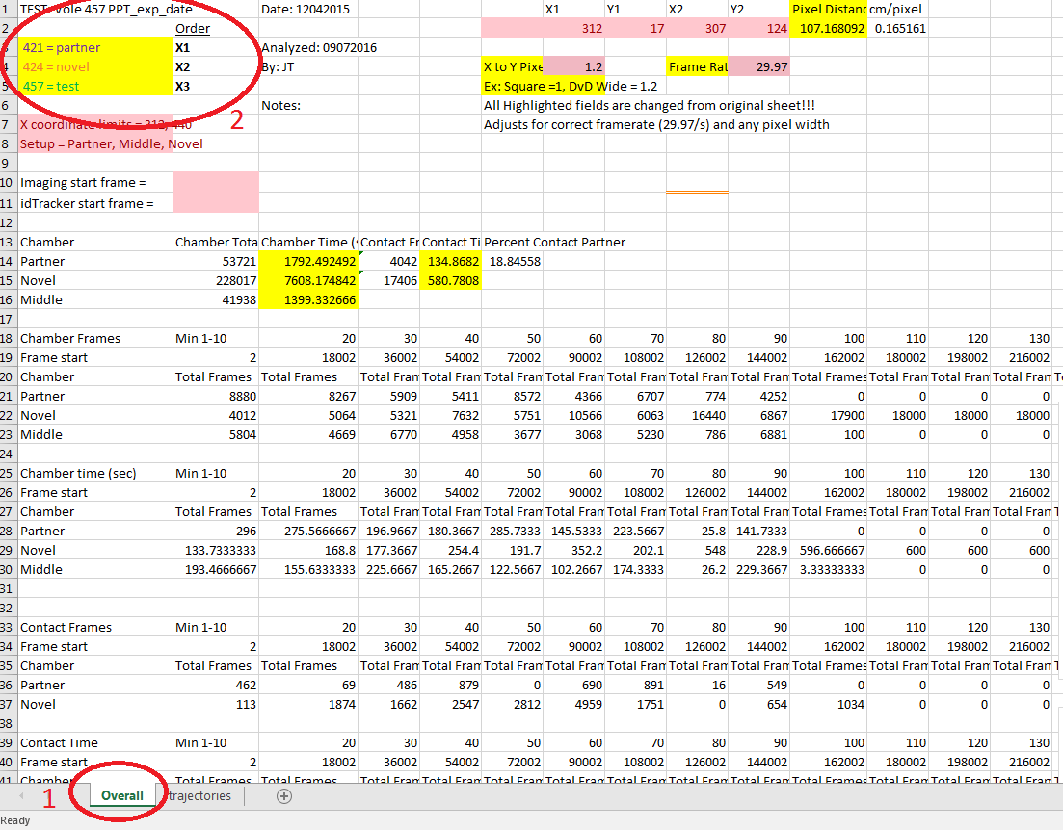

10) under “order”: the number that was assigned during tracking should correspond with the “Order” number.
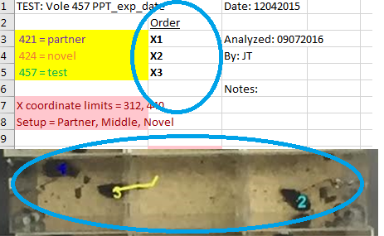
11) Next, set the X coordinate limits. This will be the 2 X-coordinates found at the top of your diagram box.
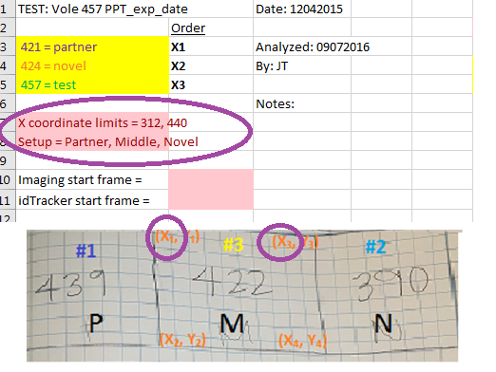
12) To the right of this info, there will be a red box and above it you will see X1, Y1 and X2, Y2. Fill in the red box with the coordinates you have the left side of your box.
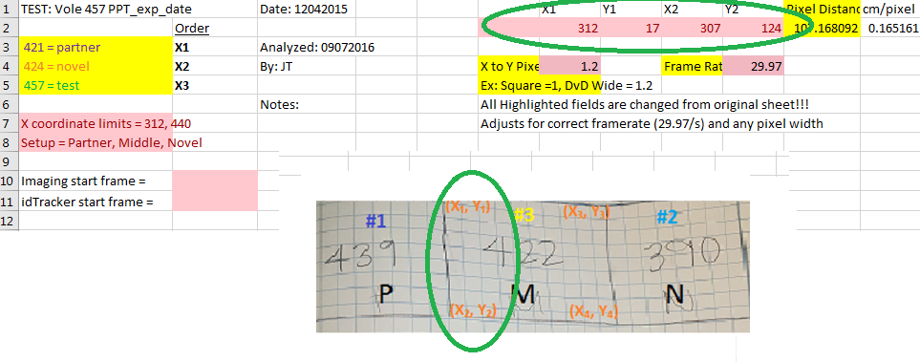

13) return to Vole # file
14) Right click the file that says “trajectories_nogaps.txt”
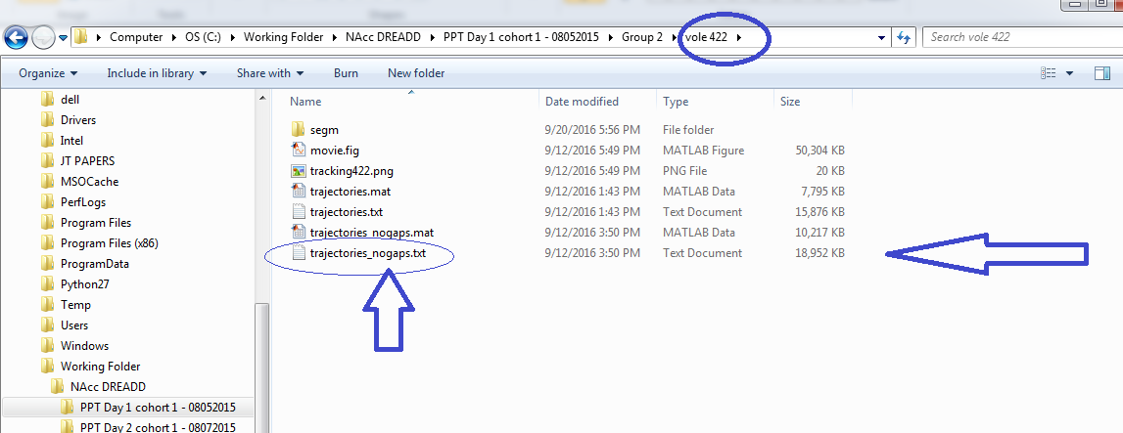
-Go down to the “open w/” button and select “open w/ excel”
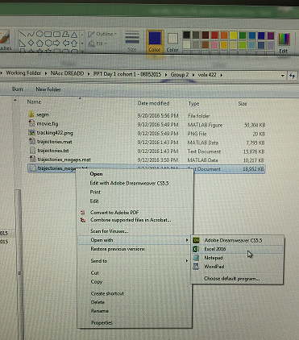

15) Find the starting frame and get rid of the all the NaN cells that are before the first frame (you should make note of the starting frame when you run the ID Tracker program to make this part easier…but it is normally somewhere between 500-800.)
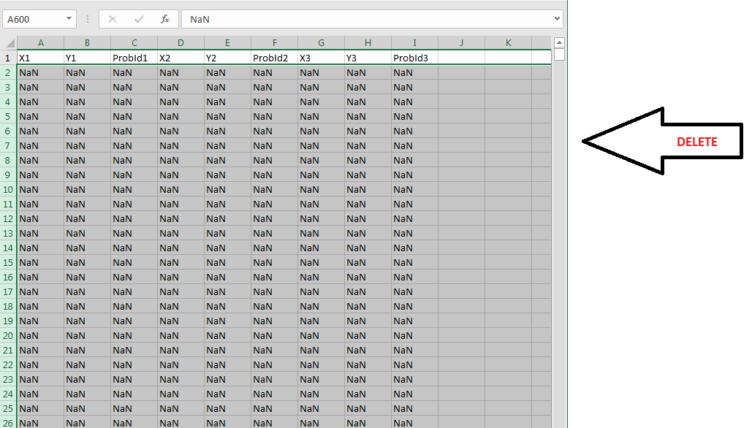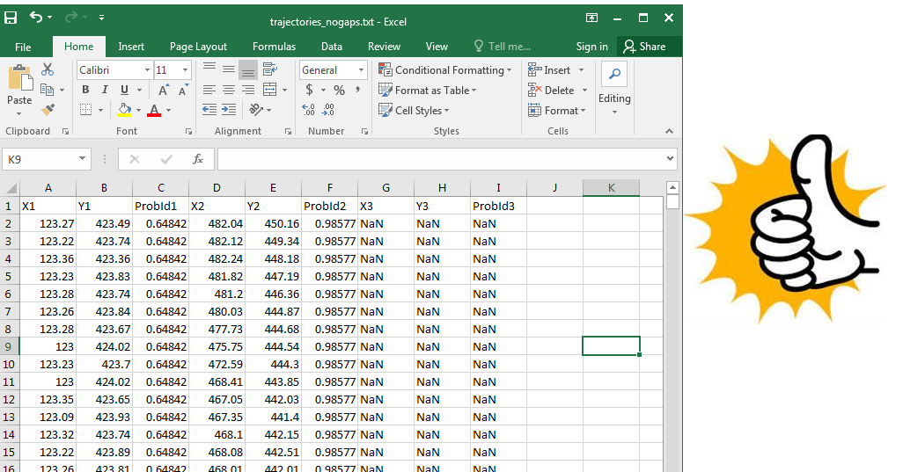
BEFORE AFTER
16) click the “trajectories” tab: delete any current probabilities already input.
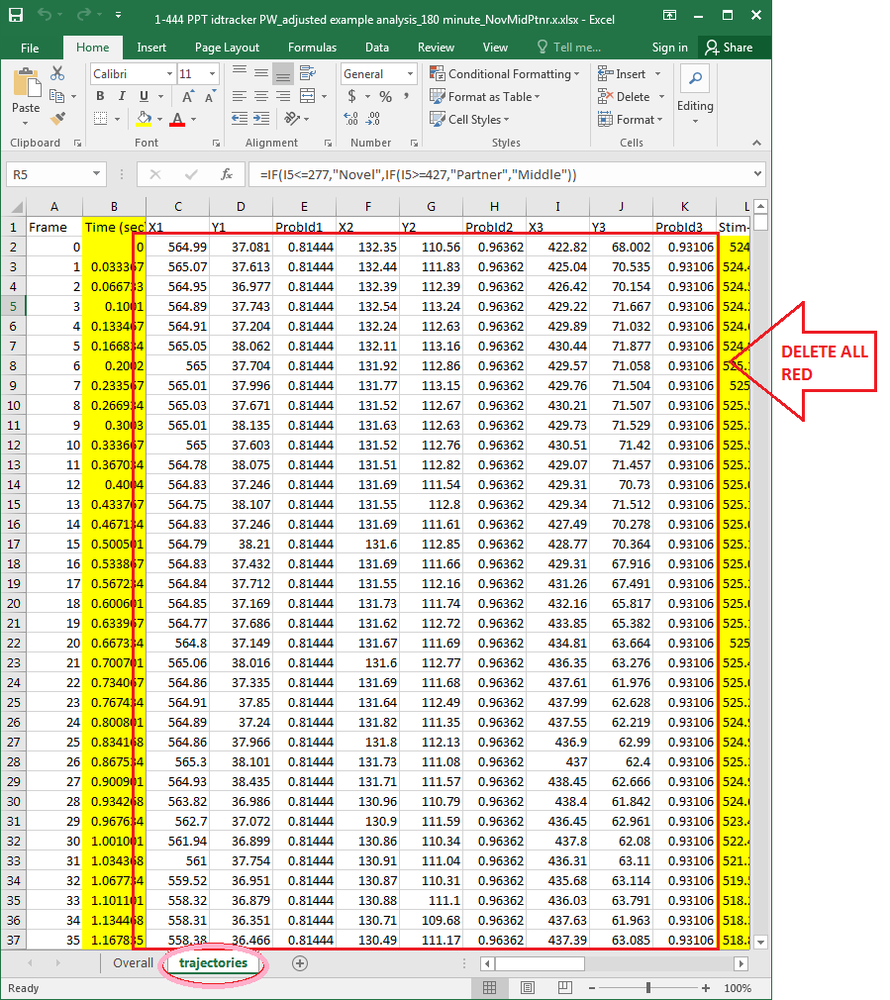

17) Input your probabilities from the “trajectories_nogaps.txt” excel file into the “PPT IDtracker PW” excel sheet. The order in which you put the probabilities in must reflect the list you have under “Order” on the first page. A good test to see if you are doing this correctly is that the Stim-Stim column should always have the biggest values, because they are the two tethered voles and cannot get any closer to each other.
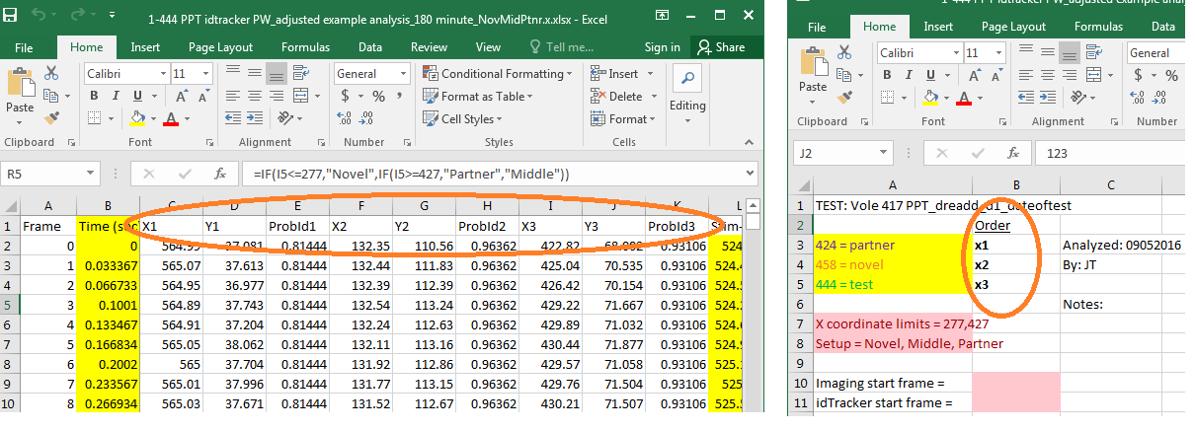

18) Next move over to the right to the “ChamberAssign” cell. Click the cell right underneath it and in the text bar there will be an equation. These values need to reflect the “X coordinate limits” you have on the first “overall” tab.
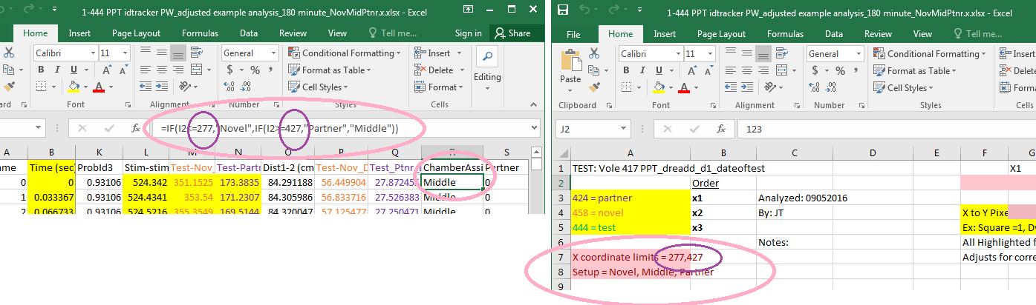

19) Congratualtions! You have successfully analyzed 1 vole’s tracking. Return back to the “Overall” tab and record the “Chamber Time”, the “contact time” (numbers are in yellow) and the “Percent contact Partner” values into your lab notebook next to your original diagram.
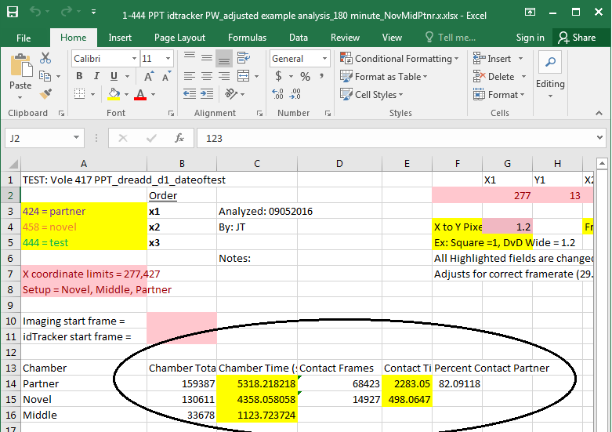
20) Get yourself a Dr. Pepper…you deserve it

